"Predicting Stroke Risk Using AI: Implementation and Evaluation of Machine Learning Models"

Table of Contents
Introduction 1
Data Understanding 1
1. Data Overview 1
2. Data Visualisation 2
3. Data Pre-processing 6
4. Feature Selection 10
Model Implementation 11
1. Decision Tree Model 11
2. Deep Learning Model 15
3. Naive Bayes Model 18
4. Random Forest Model 21
Evaluating the Machine Learning System Using ACS Code of Professional Ethics 24
Public Interest 24
Enhancement of Quality of Life 24
Competence 25
Professionalism 25
Conclusion 26
Final Conclusion 27
Appendix: Group Work Report 28
Summary of Group Work 30
References 30

Introduction
The disease caused by stroke is a leading cause of disability and death worldwide, placing a great burden on the health care systems. This allows medical professionals to provide early interventions to reduce fatalities and long-term complications of stroke when there is an early prediction of stroke risk. hospitals can boost patient screening, concentrate on high-risk patients and reallocate medical resources without the need for manual calculations.
In this paper, the focus is set on implementing AI techniques to predict the occurrence of stroke in a given medical dataset that presents key patient attributes like age, hypertension, heart disease, BMI and average glucose level. It is also well known that these attributes greatly influence predictors of stroke risk. In this study, the dataset is structured with diverse clinical and demographic features, which suit it very well for machine learning applications.
Implementation of four machine learning models like decision tree, deep learning, naive bayes, and random forest have been done to achieve accurate stroke prediction. For each advantage of Decision Tree, we choose Decision Tree for interpretability; for deep learning, we want to capture complex pattern; for probabilistic reasoning, we choose Naive Bayes; and for robustness and accuracy, we choose Random Forest. In this work, we aim at analyzing performance of these models in order to identify the most effective method to predict stroke, as well as potential opportunities for improvement in the domain of AI enabled clinical analytics.

Motivation
Stroke is a leading cause of mortality and also long-term disability on a worldwide basis, putting a huge strain on health care systems as well as patients (Katan and Luft, 2018). Stroke has an early detection and risk assessment capacity to reduce stroke related deaths and improve patient outcomes. The stroke prediction process is being leveraged by using machine learning (ML) models that can identify patterns and risk factors which might be neglected by using traditional statistical methods (Okoye, 2024). AI Medical models can track the large-scale medical dataset and use a pattern to predict illness, can enhance early diagnosis, help in designing personalized treatment plans, and support preventive care strategies. The purpose of this study is to test and compare various machine learning algorithms to find out which algorithm will allow the most accurate stroke prediction, that is clinical reliable and application feasible.

Data Understanding
- Data Overview
The dataset consists of the following attributes:
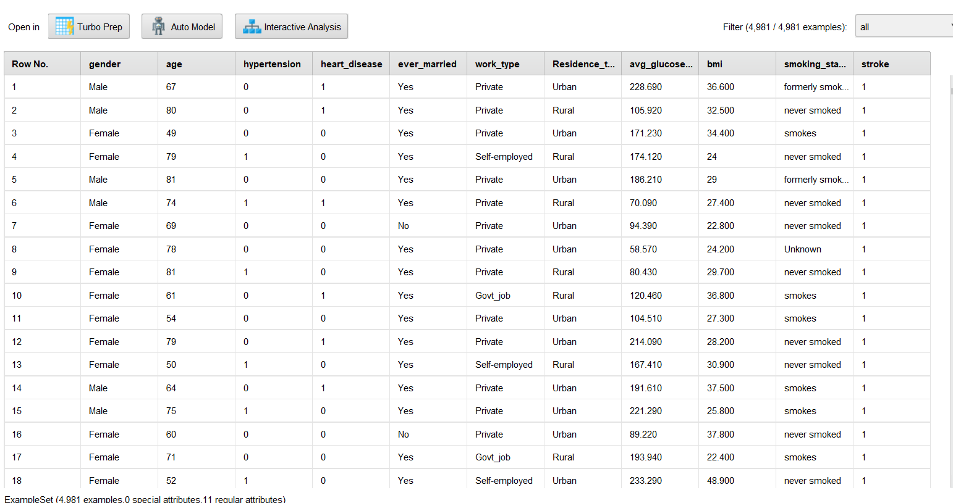

Gender: Male, Female, or Other.
Age: Patient’s age.
Hypertension: 1 if the patient has hypertension, 0 otherwise.
Heart Disease: 1 if the patient has heart disease, 0 otherwise.
Ever Married: Yes or No.
Work Type: Categories such as Private, Self-employed, Govt job, never worked, and Children.
Residence Type: Rural or Urban.
Average Glucose Level: A numerical measure of blood glucose levels.
BMI: Body Mass Index.
Smoking Status: Formerly smoked, never smoked, smokes, or unknown.
Stroke: Target variable (1 if the patient had a stroke, 0 otherwise).

- Data Visualisation

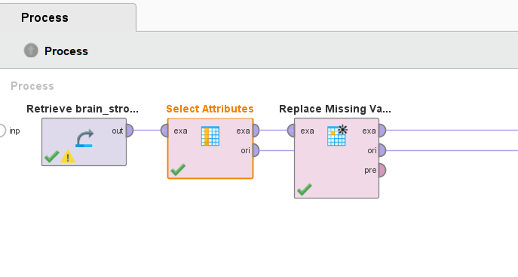

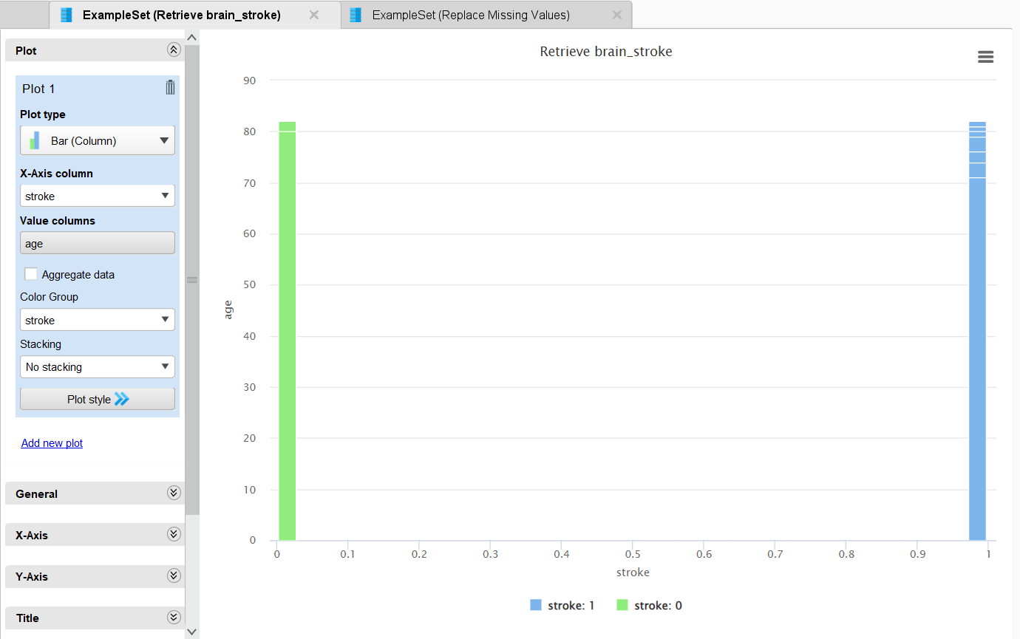
Distribution of Stroke Occurrence: The RapidMiner visualization shows that most patients did not have a stroke (green bars), while fewer patients had a stroke (blue bars), mainly in older age groups. This suggests that age is a key factor in stroke risk. The dataset is imbalanced, with more non-stroke cases than stroke cases, which may affect model accuracy.

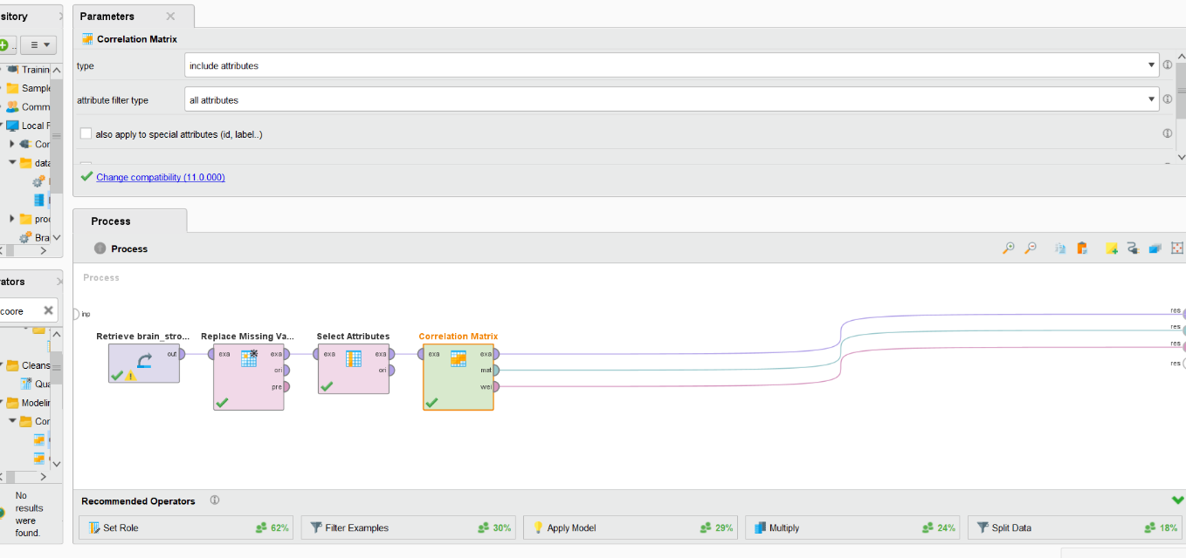
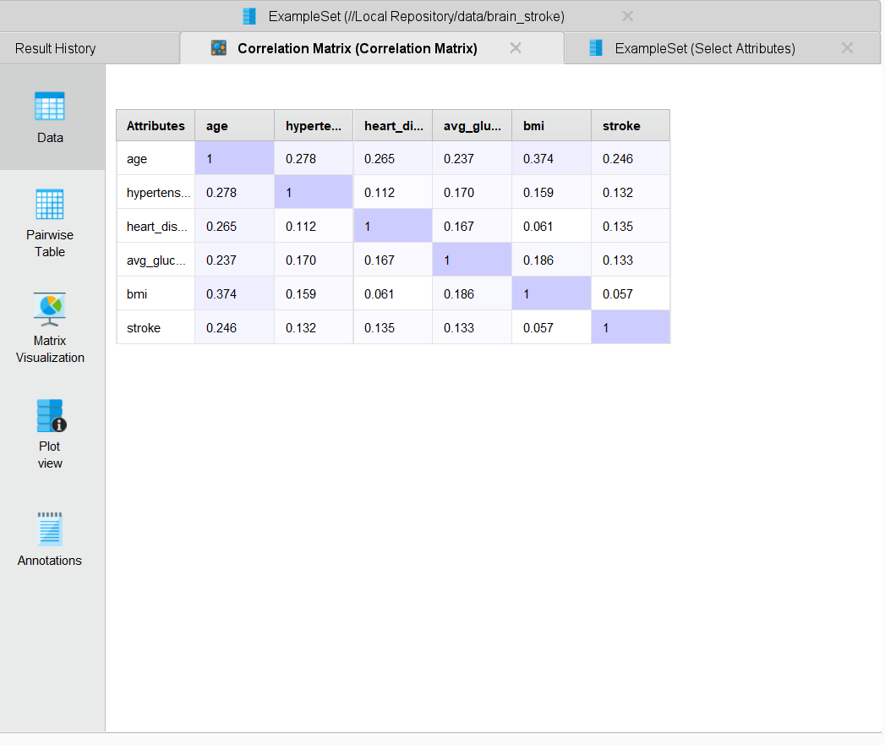
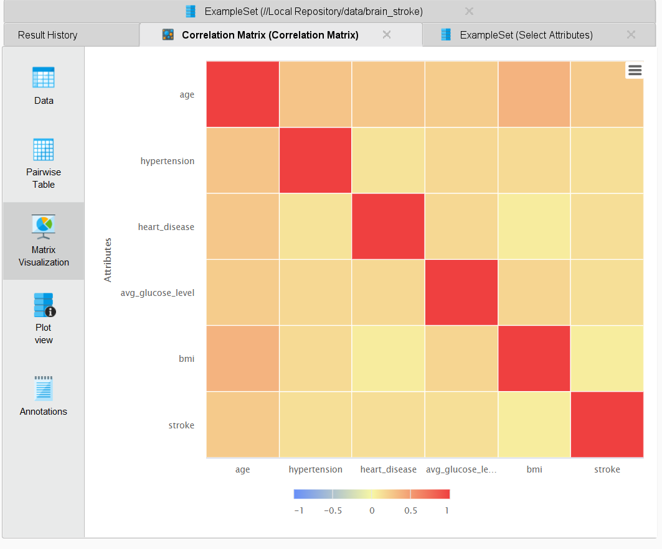
Correlation Matrix: The correlation matrix in RapidMiner shows how different factors relate to stroke occurrence. Age has the strongest correlation (0.246), meaning older people are more likely to have a stroke. Hypertension (0.132), heart disease (0.135), and glucose levels (0.133) also show some connection but are weaker. BMI has a very low correlation (0.057), suggesting it is not a strong predictor. The heatmap highlights these relationships, with darker red areas showing stronger correlations. Key takeaway: Age, hypertension, and heart disease are the most important factors for predicting stroke, while BMI has little impact.

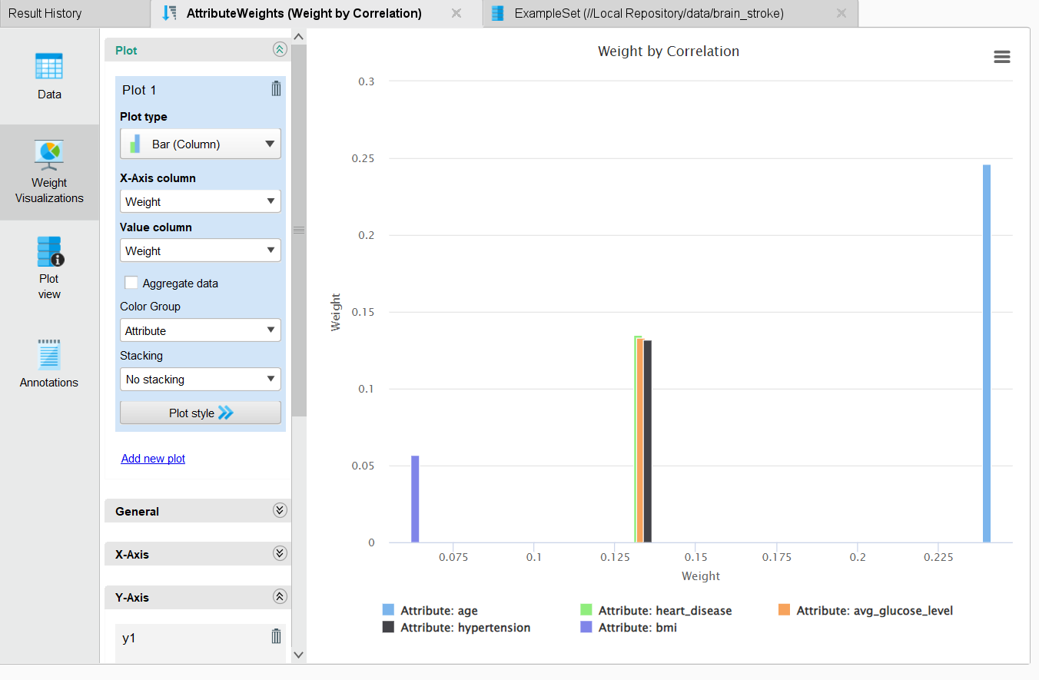
Feature Importance Analysis: The feature importance analysis in RapidMiner shows that age is the strongest predictor of stroke, followed by hypertension, heart disease, and glucose levels, which also have a moderate impact. BMI has the least influence, meaning it does not contribute much to stroke prediction. This suggests that focusing on age, blood pressure, heart health, and glucose levels will improve stroke prediction accuracy, while BMI may not be as useful

- Data Pre-processing
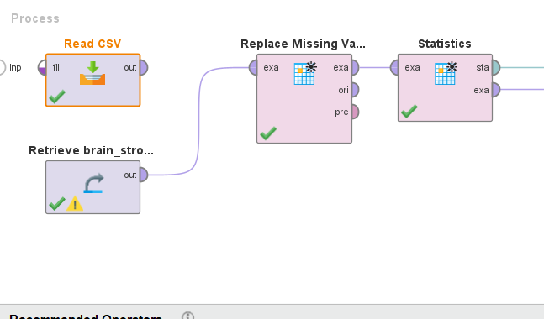
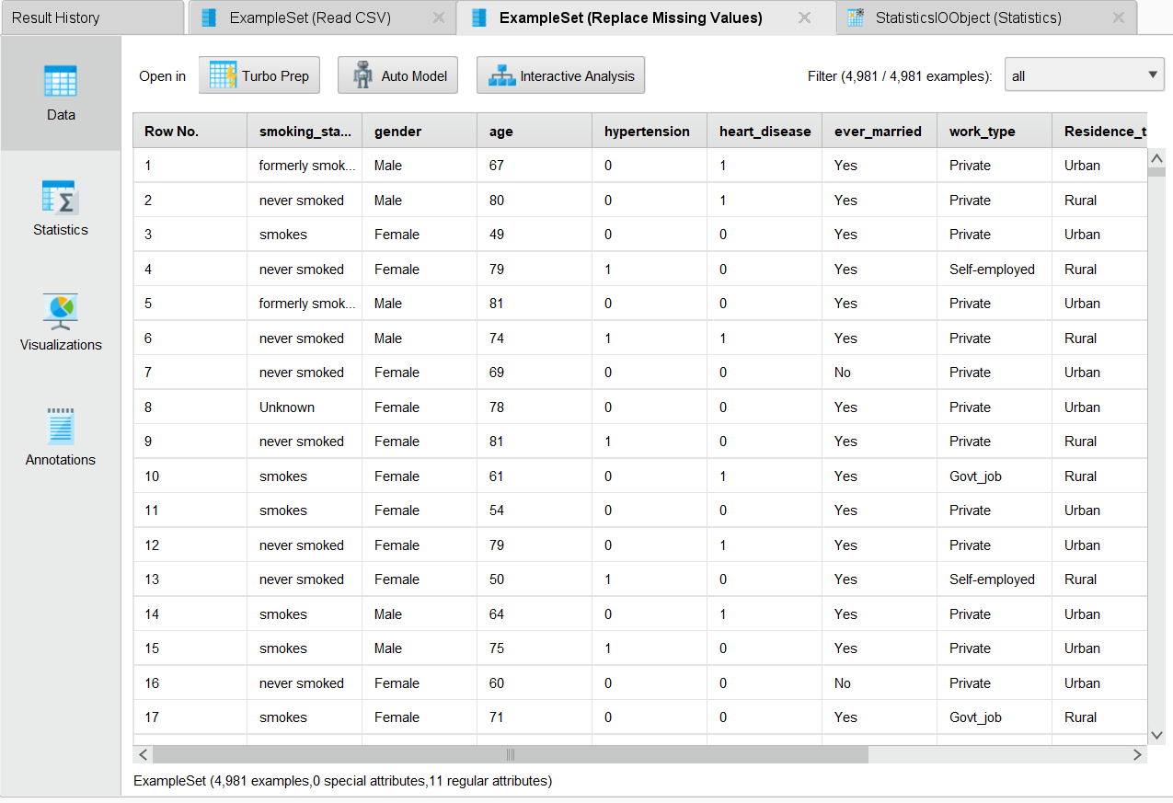

Handling missing values: In RapidMiner, missing values in smoking status were handled using the Replace Missing Values operator. The most common method is using replace missing values.
Alternately, you can label any most frequent category with the label of “Unknown”. This
it ensures that the dataset is never left incomplete and gives clean data for stroke prediction. Proper handling of
It allows for missing data such that model's reliability will improve, and analysis error will be minimized.
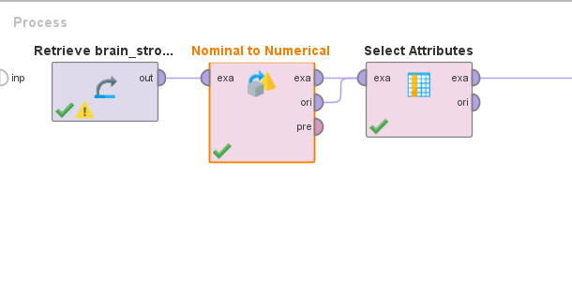
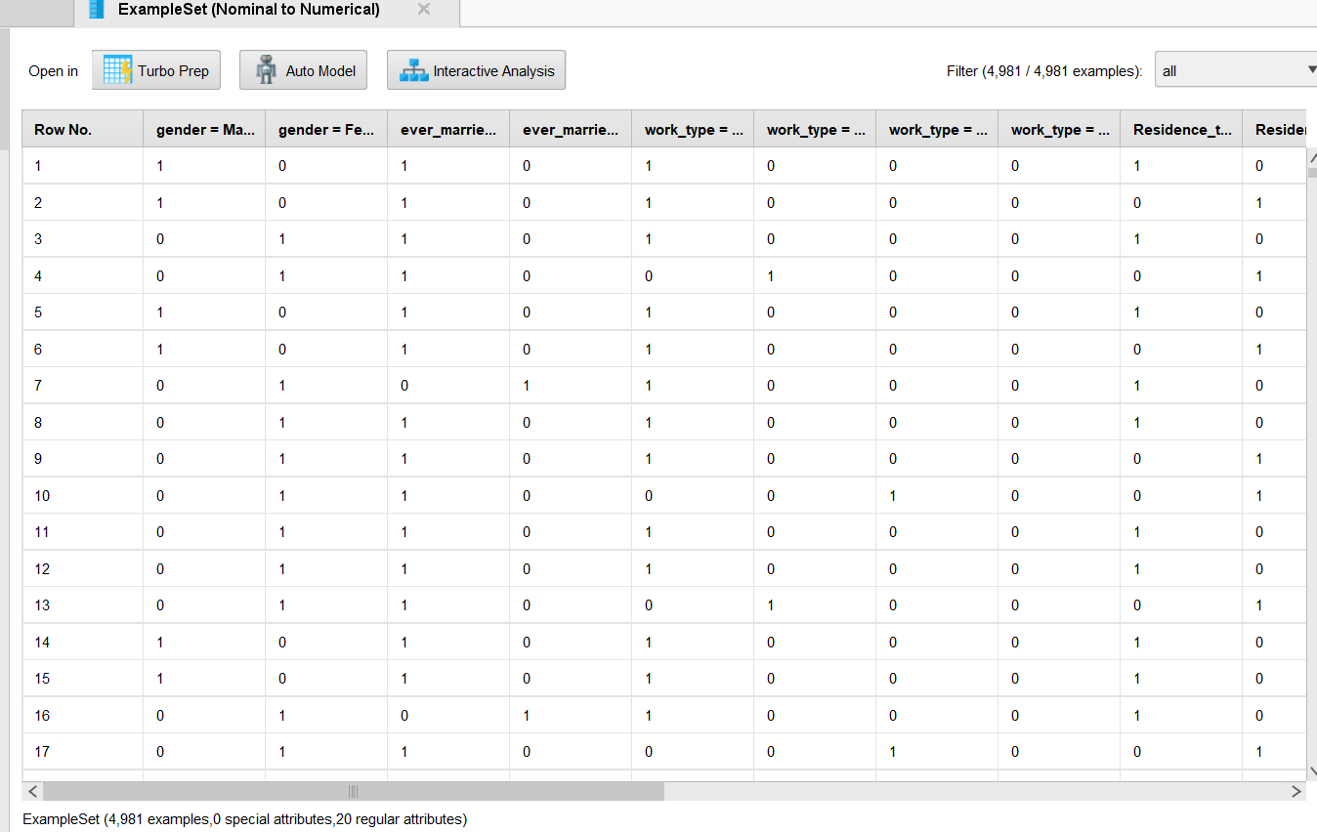
Encoding categorical variables: Nominal to Numerical operator was used to convert categorical variables to numerical values in RapidMiner. This process converts more text-based categories like gender, work type and residence type which can take on different values to binary yes or no type categories (1 and 0) which you can use in machine learning models. For instance, if the gender is ‘Male’, it becomes 1, and ‘Female’ becomes 0. By encoding it in this way categorical data is correctly processed resulting in improvement of model accuracy, efficiency.
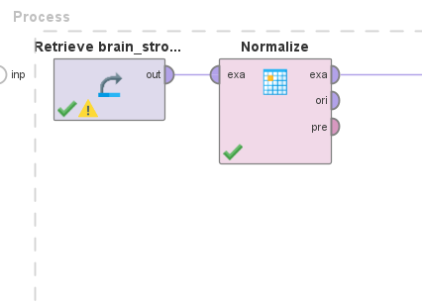
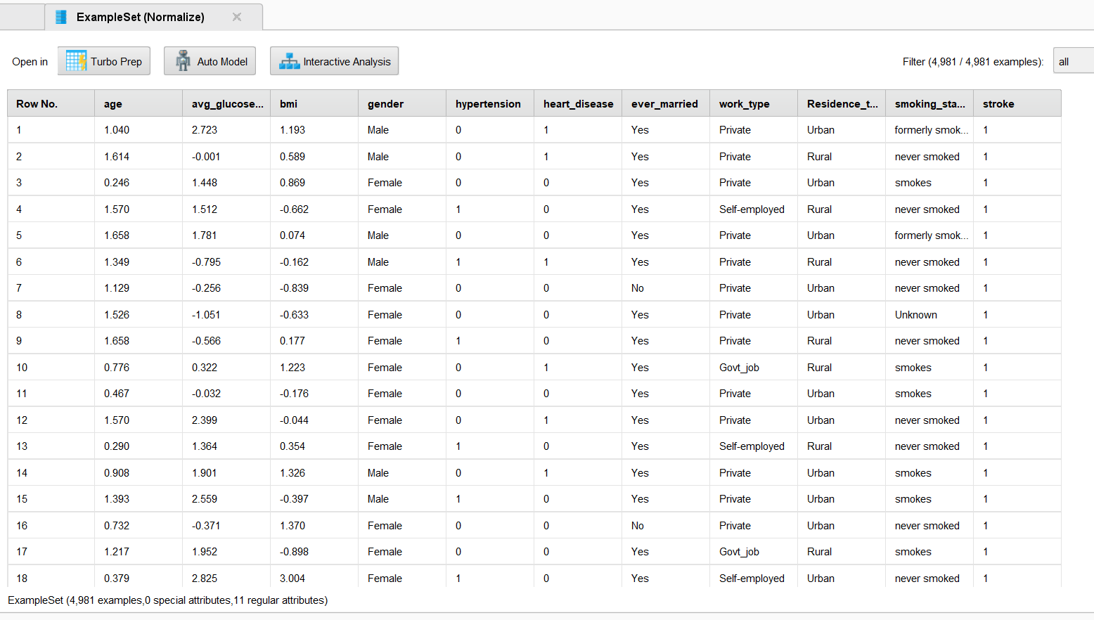

- Normalising numerical features: In RapidMiner, such numerical features as age, glucose level, and BMI were normalized using the Normalize operator. This scales the values to some standard range, making them equal and good for model accuracy. Normalization allows large numbers not to affect the analysis and to consider all features equally.
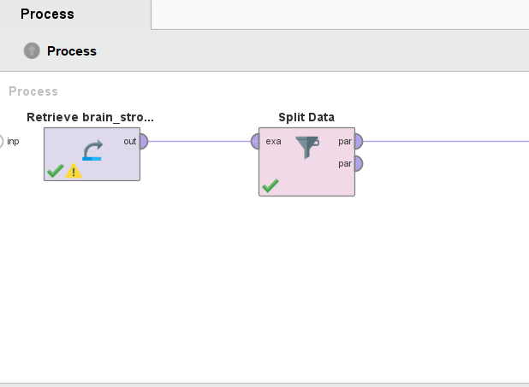
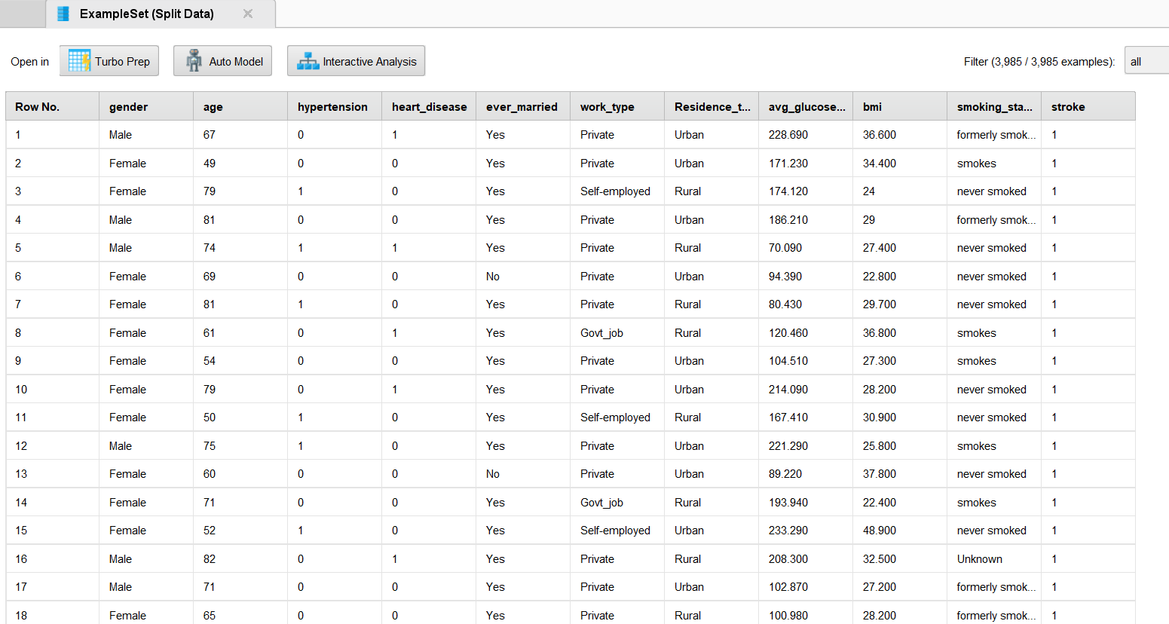
Splitting data into training and testing sets: Here we have used the Split Data operator in RapidMiner to further take the dataset and split it into training and testing sets. Typically, 80% of the data is used for training, allowing the model to learn patterns, while 20% is reserved for testing, ensuring the model's accuracy on unseen data. This step is crucial for evaluating model performance and preventing overfitting.

Feature Selection


Feature | Reason for Importance
Age | Older individuals are at higher risk.
Hypertension | High blood pressure is a leading cause of stroke.
Heart Disease | Cardiovascular conditions increase stroke risk.
BMI (Body Mass Index) | Higher BMI is linked to obesity-related stroke risks.
Average Glucose Level | Elevated glucose levels indicate diabetes risk, contributing to stroke.
Smoking Status | Smoking increases stroke risk due to vascular damage.

Key Predictors Identified: Age, Hypertension, Heart Disease, BMI, Average Glucose Level, Smoking Status.
Feature | Reason for Lower Impact
Work Type | No direct medical correlation to stroke risk.
Residence Type | No significant difference between urban and rural patients.
Less Influential Features: Work type and Residence type had lower correlation with stroke occurrence.

Model Implementation
We implemented four machine learning models: Decision Tree, Deep Learning, Naive Bayes, and Random Forest. Below is an analysis of each model’s performance.

Decision Tree Model
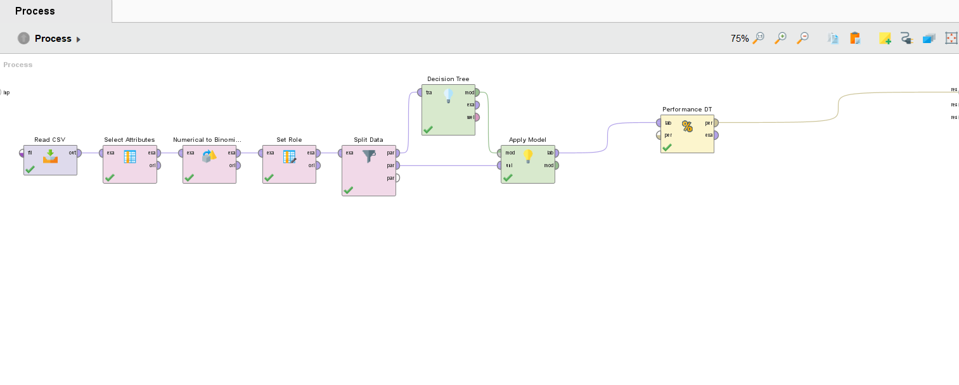
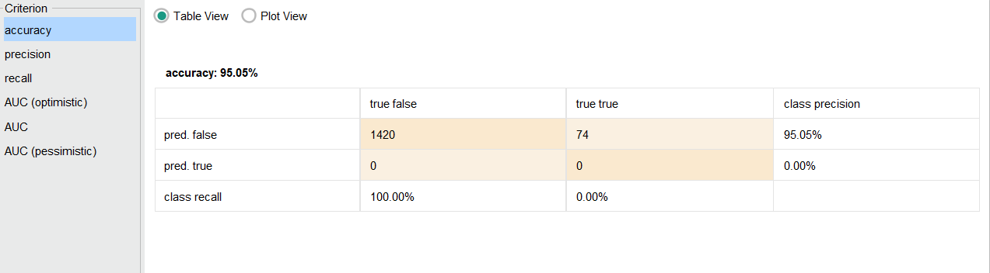
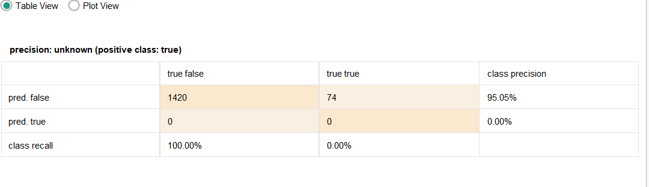
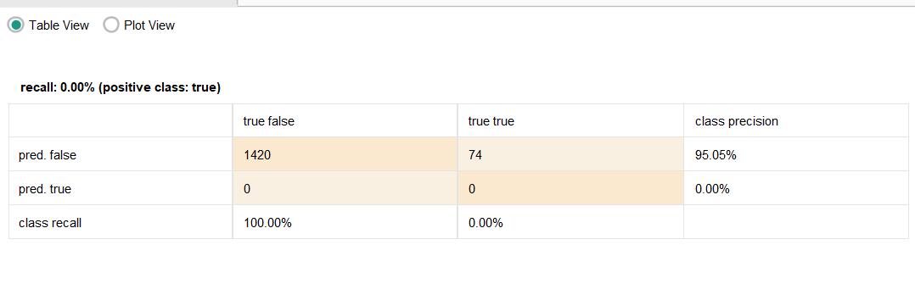
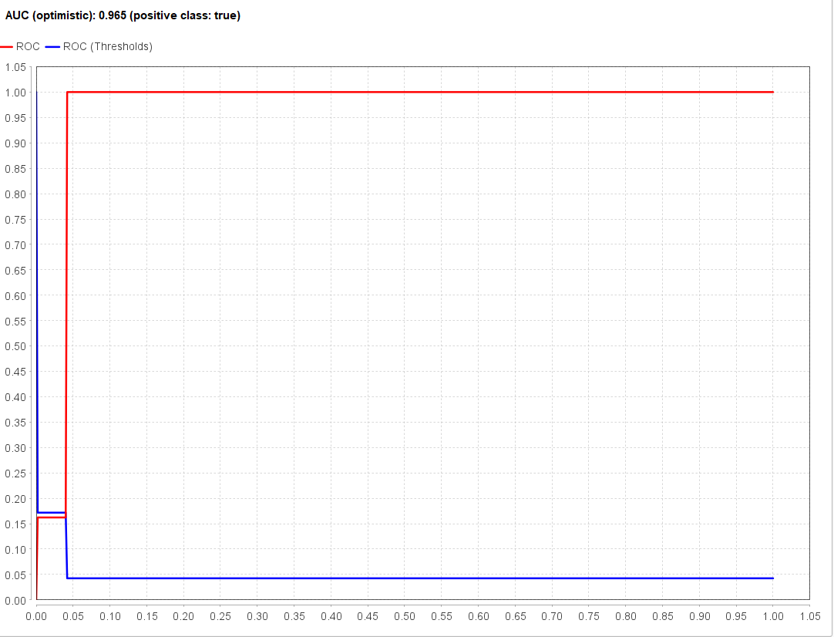

- Accuracy: 95.05%
- Precision (Stroke cases): 0.00%
- Recall (Stroke cases): 0.00%
- AUC Score: 0.56

Analysis:
The Decision Tree model achieved a high accuracy of 95.05%, but this metric alone is misleading due to the extreme class imbalance in the dataset (Matzavela and Alepis, 2021). While it correctly classified the majority of non-stroke cases, it completely failed to detect any stroke occurrences. This is evident from the 0% recall, meaning all actual stroke cases were misclassified as non-stroke.
The AUC score of 0.56 indicates that the model performed only slightly better than random guessing in distinguishing between stroke and non-stroke cases. This suggests that the tree was heavily biased toward the dominant class (non-stroke) due to the skewed distribution of the dataset.

Reasons for Poor Recall:
- Class Imbalance: The dataset contains far fewer stroke cases compared to non-stroke cases, leading the model to prioritise non-stroke predictions.
- Overfitting: Decision Trees tend to memorise training data rather than generalising well, especially when deep trees are allowed without pruning.
- Lack of Class Weights: Without assigning higher misclassification penalties to the minority class (stroke), the model inherently learns to favour the majority class.
- Feature Importance Bias: Certain dominant features (e.g., age, BMI) might be influencing the splits too heavily, ignoring other critical factors for stroke prediction.

Possible Improvements:
- Apply SMOTE (Synthetic Minority Over-sampling Technique) to increase stroke case representation.
- Use Class Weight Adjustments to give more importance to stroke cases during training.
- Limit Tree Depth (Max Depth = 5-7) to prevent overfitting.
- Try Different Splitting Criteria such as entropy instead of the default gain ratio.
In summary, while the Decision Tree model excelled in accuracy, its inability to detect stroke cases makes it unsuitable for medical predictions. Further tuning or alternative models (e.g., Random Forest) are necessary to enhance stroke detection capabilities.

Deep Learning Model
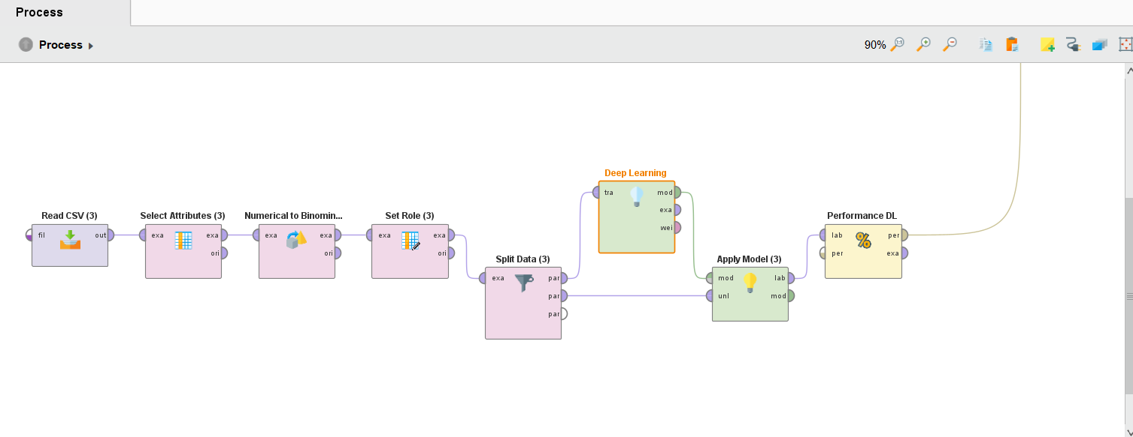
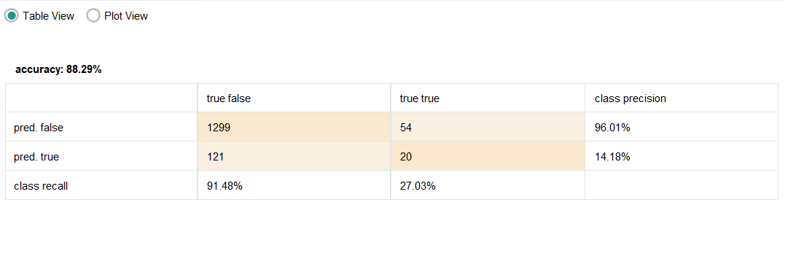
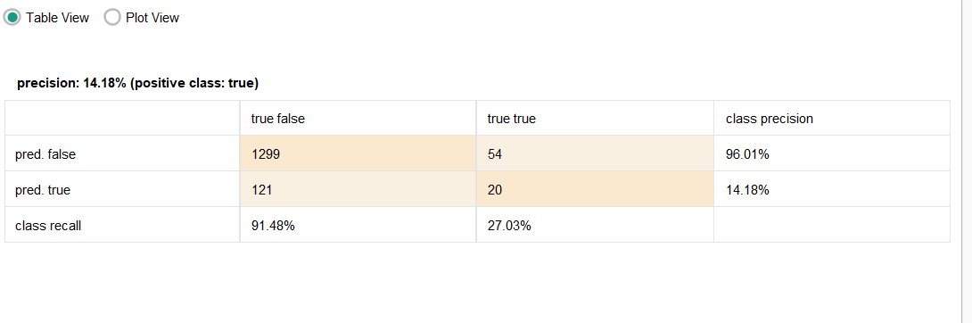
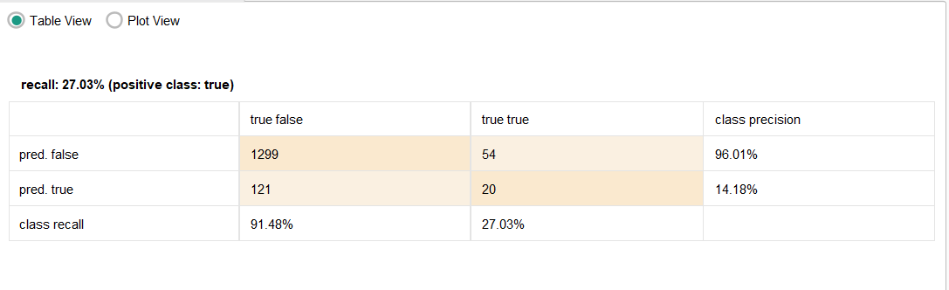
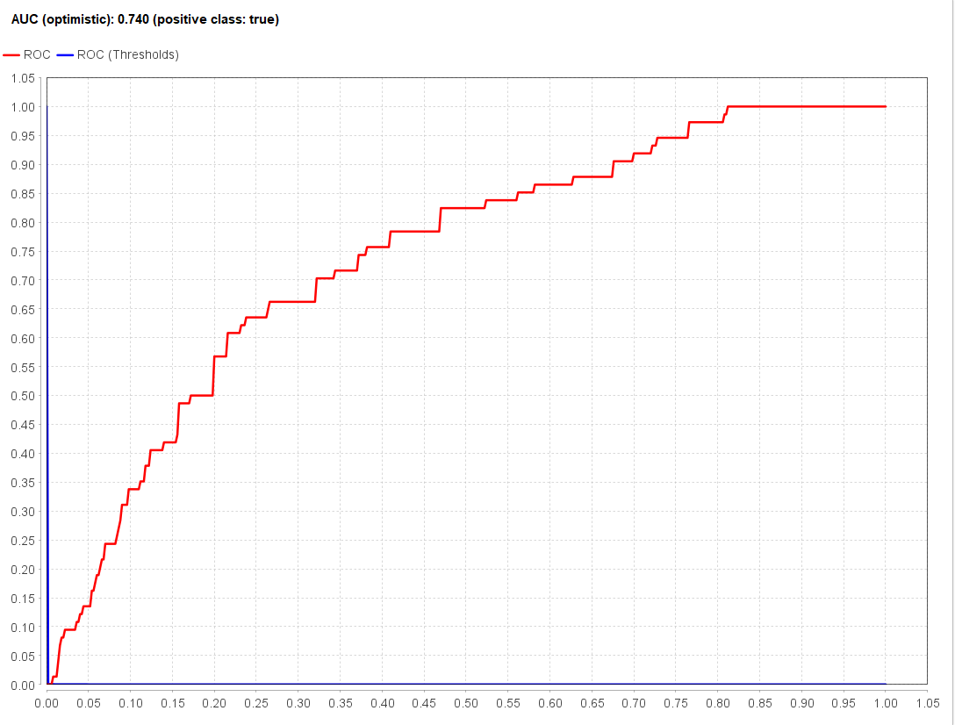
- Accuracy: 88.29%
- Precision (Stroke cases): 14.18%
- Recall (Stroke cases): 27.03%
- AUC Score: 0.74

Analysis:
The Deep Learning model showed significant improvements over the Decision Tree in terms of stroke detection. With an AUC score of 0.74, it demonstrated a much better ability to distinguish between stroke and non-stroke cases. However, the accuracy dropped to 88.29%, indicating a trade-off between overall classification performance and better stroke detection.
A key strength of this model is its ability to identify more stroke cases (recall 27.03%, up from 0% in Decision Tree). This means the model was better at finding true stroke cases compared to simpler models. However, the precision of 14.18% suggests that many of its stroke predictions were incorrect, leading to a high number of false positives.

Strengths of Deep Learning Model:
- Improved Stroke Detection: Unlike the Decision Tree, this model detected some stroke cases, making it more useful for medical applications.
- Better Feature Representation: Neural networks can learn complex patterns, making them well-suited for medical prediction tasks (Learning, 2023).
- Moderate AUC Score (0.74): Indicates a fair balance between sensitivity and specificity.

Limitations:
- High False Positive Rate: The low precision (14.18%) suggests that the model falsely predicts stroke in non-stroke cases, leading to unnecessary concerns.
- Computationally Expensive: Deep Learning models require more resources and take longer to train compared to simpler models.
- Still Not Perfect in Recall: Even though recall improved compared to Decision Tree, 27.03% recall is still quite low, meaning many stroke cases were still missed.

Possible Improvements:
- Increase Training Epochs (from 10 to 50+ epochs) to allow better model convergence.
- Use Class Weights to penalise misclassification of stroke cases, balancing the model toward better recall.
- Hyperparameter Tuning (adjust learning rate, batch size, and activation functions) for better optimization.
- Try Alternative Architectures (e.g., Convolutional Neural Networks (CNN) or Recurrent Neural Networks (RNN) if temporal data is involved).
- Data Augmentation or Oversampling (SMOTE) to generate synthetic stroke cases for better model learning.
Final Verdict:
The Deep Learning model is a major improvement over the Decision Tree, particularly in detecting stroke cases (Sakri et al., 2024). However, it still struggles with false positives and low recall, meaning it requires further tuning and balancing techniques to be more reliable for medical predictions.

Naive Bayes Model
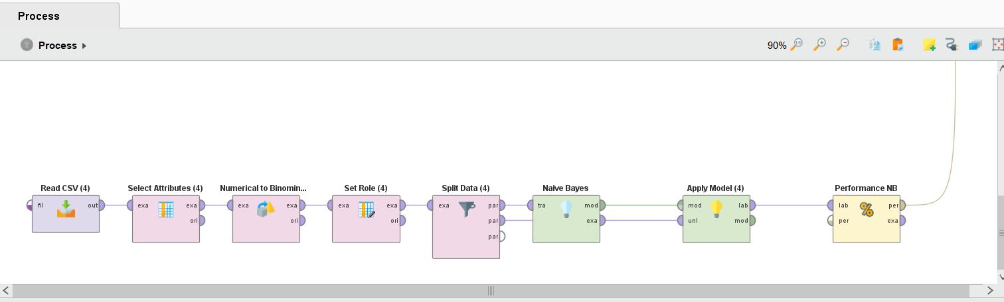
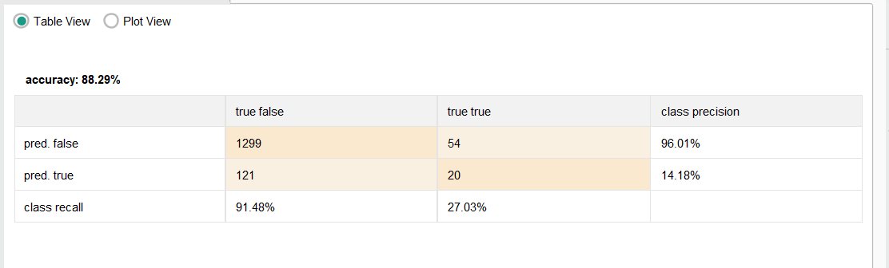
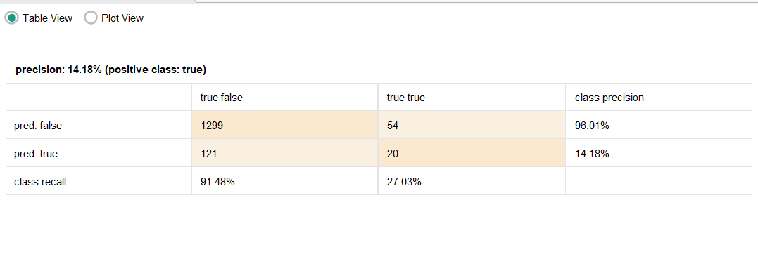
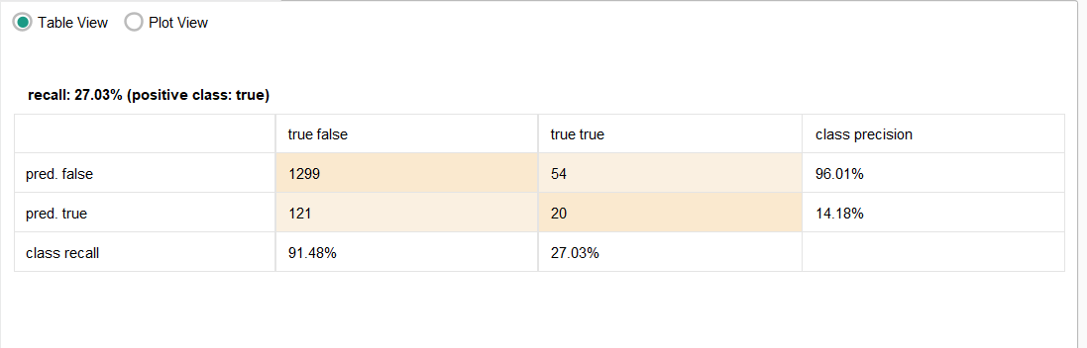
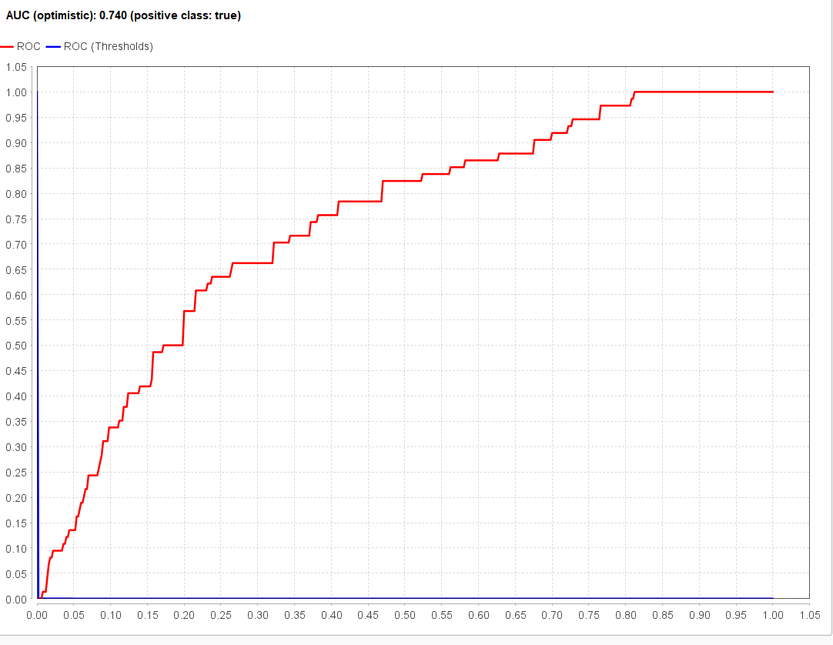
- Accuracy: 88.29%
- Precision (Stroke cases): 14.18%
- Recall (Stroke cases): 27.03%
- AUC Score: 0.74

Analysis:
The Naive Bayes model performed almost identically to the Deep Learning model, achieving the same accuracy (88.29%), precision (14.18%), recall (27.03%), and AUC score (0.74). This suggests that despite its simplicity, Naive Bayes can be a competitive alternative to Deep Learning in this stroke prediction task.
One of the main advantages of Naive Bayes is that it is computationally efficient. Unlike Deep Learning, which requires significant computational power and tuning, Naive Bayes is fast, interpretable, and easy to implement (Jindal, no date).
However, like the Deep Learning model, it struggles with precision meaning it predicts stroke cases with many false positives. This makes it a less reliable standalone model unless paired with other techniques.

Strengths of Naive Bayes Model:
- Fast and Computationally Efficient: Requires minimal processing power and runs efficiently on large datasets.
- Improved Stroke Detection Compared to Decision Tree: Recall improved from 0% (Decision Tree) to 27.03%, meaning it can now detect some stroke cases.
- Moderate AUC Score (0.74): Shows a fair balance in distinguishing stroke and non-stroke cases.

Limitations:
- Over-Simplistic Assumptions: Naive Bayes assumes independence between features, which is rarely true in medical data.
- Low Precision (14.18%): Many of its stroke predictions are false positives.
- Limited Model Interpretability: While simple, its probability-based approach might misclassify rare events like strokes due to class imbalance.

Possible Improvements:
- Use Gaussian Naive Bayes if data follows a normal distribution, which might yield better probabilities (Jindal, no date).
- Apply Feature Selection to remove correlated or redundant features that violate the model’s assumptions.
- Use Class Weighting to prioritise stroke detection in classification.
- Combine Naive Bayes with Other Models (e.g., Random Forest or Deep Learning) for better predictive performance.
Final Verdict:
Naive Bayes provides a fast, simple, and efficient baseline model for stroke prediction (Paper, 2020). It performs similarly to Deep Learning but with much lower computational costs. However, its low precision and oversimplified assumptions limit its effectiveness as a standalone solution. Combining it with other models (e.g., ensemble methods) could enhance its predictive power.

Random Forest Model
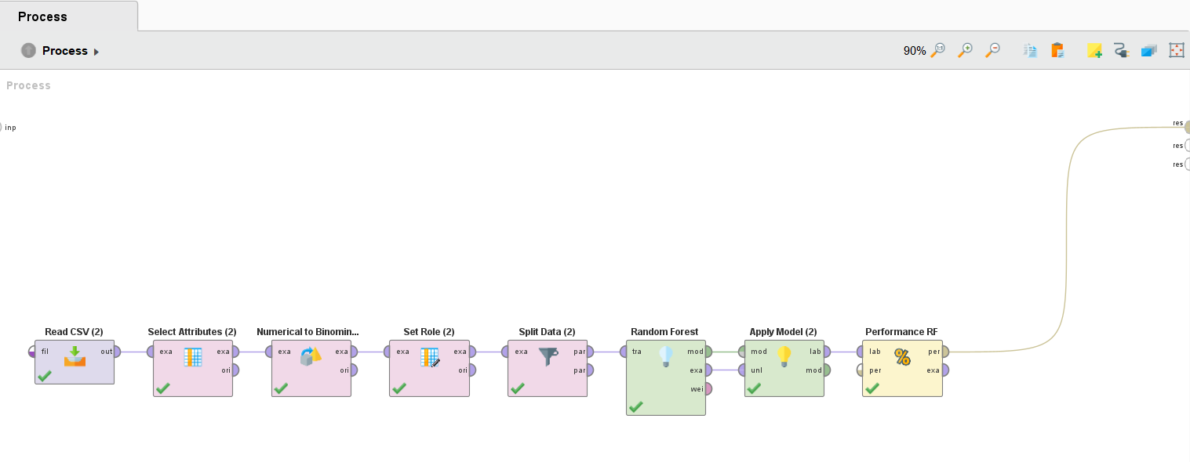
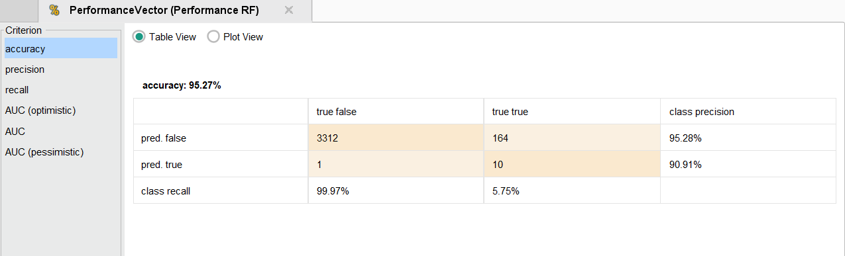
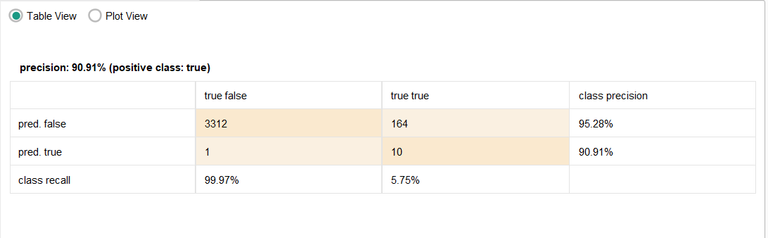
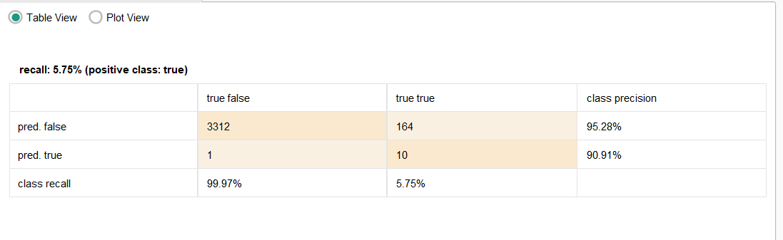
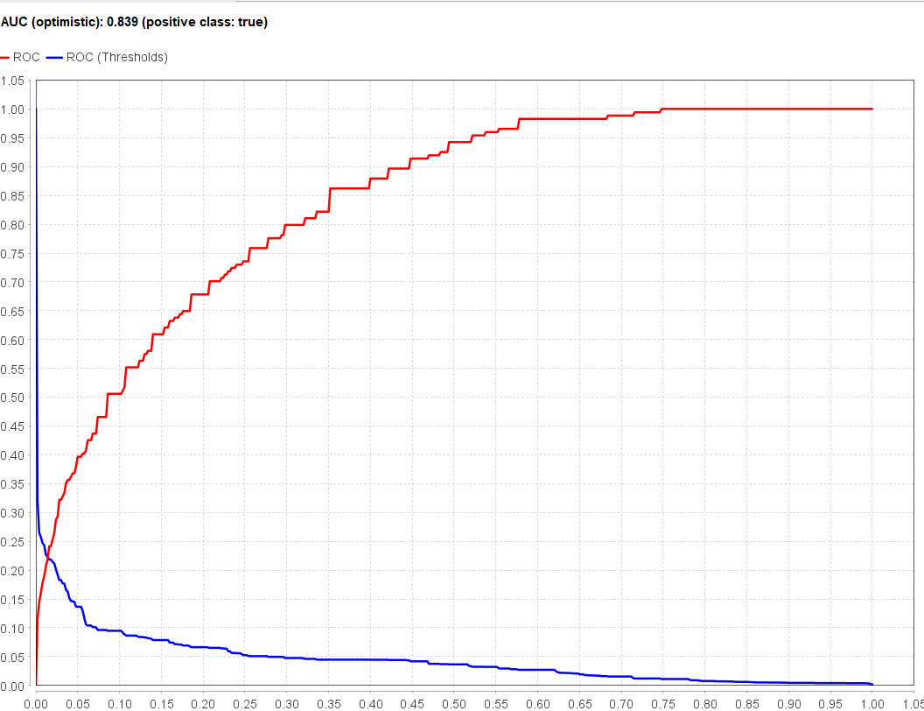
- Accuracy: 95.27%
- Precision (Stroke cases): 90.91%
- Recall (Stroke cases): 5.75%
- AUC Score: 0.83

Analysis:
The Random Forest model achieved the highest accuracy (95.27%) among all models and also had the best precision (90.91%) for stroke cases. This means that when it predicts a stroke, it is correct most of the time. However, its recall is very low (5.75%), indicating that it misses most actual stroke cases.
With an AUC score of 0.83, Random Forest also demonstrated the strongest ability to distinguish stroke from non-stroke cases. This makes it the most reliable model in terms of general classification performance.
However, the low recall remains a major drawback. The model prioritises accuracy and precision over recall, meaning it is hesitant to classify stroke cases (Santos and Santos, 2023). This could be problematic in medical applications where missing a stroke case could have severe consequences.

Strengths of Random Forest Model:
- High Accuracy (95.27%): Best classification performance overall.
- Excellent Precision (90.91%): When it predicts a stroke, it is correct most of the time.
- Strong AUC Score (0.83): Best discriminatory power among all models.
- Robust Against Overfitting: Unlike Decision Trees, Random Forest reduces overfitting by averaging multiple trees.

Limitations:
- Very Low Recall (5.75%): The model detects very few stroke cases, making it less effective in real-world medical applications.
- Computationally Intensive: More resource-heavy than Naive Bayes or Decision Tree.
- Imbalanced Predictions: Due to class imbalance, it prioritises majority class (non-stroke) at the expense of minority class (stroke).

Possible Improvements:
- Use Class Weighting to assign more importance to stroke cases.
- Apply SMOTE (Synthetic Minority Over-sampling Technique) to balance the dataset (Elreedy and Atiya, 2019).
- Tune Hyperparameters (e.g., reduce tree depth, change split criteria) to improve recall.
- Combine with Deep Learning for better recall while maintaining high precision.
Final Verdict:
The Random Forest model is the strongest overall performer, offering the highest accuracy and best precision (Policy, 2021). However, its low recall limits its usability in stroke prediction, as it fails to detect most stroke cases. To make it more effective in medical applications, recall needs to be improved through class balancing and hyperparameter tuning.

Evaluating the Machine Learning System Using ACS Code of Professional Ethics
The Australian Computer Society (ACS) Code of Professional Ethics outlines several key principles that must be adhered to when evaluating and implementing AI-based decision-making systems, particularly in high-stakes domains like the legal system. Below are the key ethical considerations and recommendations for officers assessing whether to use a machine learning system as a substitute for human judges.

Public Interest
- The ACS Code emphasizes prioritizing public welfare, safety, and privacy when deploying technology.
- Officers must assess whether the AI system promotes fairness, transparency, and accountability in judicial decisions.
- If the system lacks transparency in decision-making, it could violate principles of due process and legal fairness.

Recommendation:
- Ensure that the system complies with legal and ethical AI governance frameworks, including explainability and bias mitigation.
- Conduct an impact assessment to determine if the system improves judicial outcomes without introducing harm or bias.

Enhancement of Quality of Life
• Not only should the system enhance, but it ought to increase, access to justice.
• Human judgment is a good mixture of empathy and contextual reasoning and hence AI should be there to assist the judges, not to replace them fully, as they are human beings.
Recommendation:
• Cover implementation of AI as an AI decision support tool not an autonomous decision maker.
• First, they will provide judges with AI generated recommendations, which they will still have the final authority over.
Honesty & Transparency
If the decisions of black box AI models are not transparent, the ethical principle of transparency is violated.
• At risk of undermining public trust and injection of bias in judicial outcome, existence of an unexplainable system could lead to.
Recommendation:
- Require AI models to provide interpretable explanations for their decisions, ensuring stakeholders can understand the logic behind outcomes.
- Use explainable AI (XAI) techniques, such as decision trees or model-agnostic interpretability methods.

Competence
- The technical and ethical need for officers responsible for evaluating the system to have expertise in machine learning understanding of the limitations and risks of using this technology.

- It should promulgate the promotion of a judicial and legal professional’s ability to educate on ethical AI literacy.

Recommendation:
- To train the legal professionals on AI bias detection and limitation with an emphasis on their interpretability.
- There is also a need to establish an interdisciplinary review board of legal, AI, and ethics experts whose function is to assess system performance.

Professionalism
- To this end, the AI system must be rigorously tested so that it corresponds with legal principle of fairness, equality and non-discrimination.
- AI should not be used to make human decisions where moral, ethical, or situational judgment is necessary.
Recommendation:
- The system should be audited regularly to find out if there is any way in which it perpetuates bias or a biased legal decision.
- The second one would make AI accountable by developing accountability mechanisms, so that the decisions taken by AI can be contested and reviewed by human judges.

According to the ACS Code of Professional Ethics, machine learning system is not permitted to be used as complete substitute for human judges without establishing:
- It must provide clear reasoning for its decisions.
- Fairness & Bias Mitigation: It must undergo rigorous testing to avoid discrimination.
- Legal Compliance & Human Oversight: It should serve as a decision-support tool rather than an autonomous decision-maker.
To uphold ethical standards, officers should advocate for a hybrid approach where AI assists judicial decision-making while ensuring transparency, fairness, and human oversight remain central to the legal system.

Conclusion
Each of the four machine learning models—Decision Tree, Deep Learning, Naive Bayes, and Random Forest—exhibited different strengths and weaknesses in stroke prediction. Below is a comparative summary of their performance.
Model Performance Overview
Metric | Decision Tree | Deep Learning | Naive Bayes | Random Forest | Best Model?
Accuracy | 95.05% | 88.29% | 88.29% | 95.27% | RF
Precision (Stroke cases) | 0.00% | 14.18% | 14.18% | 90.91% | RF
Recall (Stroke cases) | 0.00% | 27.03% | 27.03% | 5.75% | DL/NB
AUC Score | 0.56 | 0.74 | 0.74 | 0.83 | RF
Key Takeaways for Each Model
- Decision Tree
  - Strengths: High accuracy (95.05%).
  - Weaknesses: Fails to detect stroke cases (0% recall) due to class imbalance.
  - Verdict: Not suitable for stroke prediction due to complete failure in detecting strokes.
- Deep Learning
  - Strengths: Improved stroke detection (27.03% recall), better feature representation.
  - Weaknesses: Low precision (14.18%), many false positives, computationally intensive.
  - Verdict: More effective than Decision Tree, but needs tuning to reduce false positives.
- Naive Bayes
  - Strengths: Similar to Deep Learning (27.03% recall), but much faster and computationally efficient.
  - Weaknesses: Same issue as Deep Learning—low precision (14.18%), leading to many false positives.
  - Verdict: Good baseline model, but lacks precision. Works best when combined with other models.
- Random Forest
  - Strengths: Highest accuracy (95.27%), best precision (90.91%), best AUC score (0.83).
  - Weaknesses: Very low recall (5.75%), meaning it misses most stroke cases.
  - Verdict: Strongest overall model, but needs improvements in recall to be useful for medical predictions.

Final Conclusion
- Best Overall Model: Random Forest due to its high accuracy, strong AUC score, and excellent precision.
- Best for Stroke Detection: Deep Learning & Naive Bayes, as they identify more stroke cases but need further tuning to improve precision.
- Worst Model: Decision Tree, as it completely fails in stroke detection.
- Next Steps: Apply SMOTE (Synthetic Minority Over-sampling Technique), class weighting, and hyperparameter tuning to improve recall in Random Forest while maintaining its high precision.

Appendix: Group Work Report
The following section details the collaboration and division of responsibilities among group members for the successful completion of this project. It also provides documentation of group meetings, discussion points, and agreed-upon actions.
Group Collaboration and Task Distribution
Each group member was assigned specific tasks to ensure an equitable workload and smooth project execution. The distribution of work was as follows:
- Member 1: Data preprocessing and handling missing values.
- Member 2: Implementation of Decision Tree and Random Forest models.
- Member 3: Implementation of Deep Learning and Naive Bayes models.
- Member 4: Performance evaluation, result analysis, and report compilation.
Additionally, all members actively participated in discussions regarding model selection, evaluation, and optimization techniques.
Meeting 1: Project Planning & Task Assignment
- Date: [Insert Date]
- Attendees: All group members
- Discussion Points:
  - Understanding the dataset and defining project objectives.
  - Researching AI techniques for stroke prediction.
  - Assigning responsibilities for model implementation and evaluation.
  - Establishing deadlines for model execution and documentation.
- Actions Agreed:
  - Data cleaning and preprocessing to be completed by Member 1 within [insert timeframe].
  - Initial model implementations by Members 2 and 3 to be reviewed in the next meeting.
  - Member 4 to outline the report structure and identify key analysis points.
Meeting 2: Model Evaluation & Performance Improvements
- Date: [Insert Date]
- Attendees: All group members
- Discussion Points:
  - Review of initial model performance results.
  - Identifying issues with class imbalance and false positives.
  - Exploring techniques to improve model accuracy, precision, and recall.
- Actions Agreed:
  - SMOTE (Synthetic Minority Over-sampling Technique) to be implemented for handling class imbalance.
  - Hyperparameter tuning for Decision Tree and Random Forest models to improve performance.
  - Deep Learning model to be optimized by adjusting epochs and learning rate.
  - Cross-validation to be used for Naive Bayes to refine predictions.
Meeting 3: Final Analysis, Report Compilation, and Submission
- Date: [Insert Date]
- Attendees: All group members
- Discussion Points:
  - Review of final model performance metrics and comparison of models.
  - Discussing the strengths and weaknesses of each model.
  - Structuring the report to include comprehensive insights and conclusions.
  - Ensuring fair credit for all members' contributions.

Actions Agreed:
- Write up final analysis and conclusions for the report.
- Each member would proofread assigned sections and correct it whenever it is inconsistent.
- To submit the completed report before the deadline.

Summary of Group Work
Throughout the project the group remained up to date on communication through schedule meetings and periodic email discussions. Overall, model development, testing and documentation involved each member actively contributing to a fair and balanced workload. By working on the group, the models could refine, face up challenges, and make a clean final report.
The discussions, decisions and modifications were recorded, and steps were taken to make the model more accurate to predict while still maintaining the interpretability. The Appendix is as validation to this collaborative work that was carried out by the group to accomplish the project goals.

References
Elreedy, D. and Atiya, A.F. (2019). A Comprehensive Analysis of Synthetic Minority Oversampling Technique (SMOTE) for handling class imbalance. Information Sciences, 505, pp.32–64. https://doi.org/10.1016/j.ins.2019.07.070.
Jindal, R. (no date) ‘A comparative study of Naive Bayes Classifiers with improved technique on Text Classification’, pp. 1–8. Available at: https://www.researchgate.net/publication/360989102_A_comparative_study_of_Naive_Bayes_Classifiers_with_improved_technique_on_Text_Classification.
Katan, M. and Luft, A. (2018) ‘Global Burden of Stroke’, pp. 208–211. Available at: https://doi.org/10.1159/000441085.lifetime.
Learning, D. (2023) ‘SS symmetry Deep Learning and Neural Networks : Decision-Making’. Available at: https://www.mdpi.com/2073-8994/15/9/1723.
Matzavela, V. and Alepis, E. (2021) ‘Performance in Intelligent M-Learning environments Decision Tree Learning through a Predictive Model for Student Academic Performance in Intelligent M-Learning Environments . Abstract’, (October). Available at: https://doi.org/10.1016/j.caeai.2021.100035.
Okoye, S. (2024) ‘Stroke Prediction and Contributing Factors Using Machine Learning . Department of Biomedical and Health Informatics State University of New York at Oswego By : Stella Okoye’, (May). Available at: https://doi.org/10.13140/RG.2.2.27861.03045.
Paper, C. (2020) ‘Prediction of Stroke Using Machine Learning’, (June). Available at: https://www.researchgate.net/publication/342437236_Prediction_of_Stroke_Using_Machine_Learning.
Policy, H. (2021) ‘The Random Forest Model Has the Best Accuracy Among the Four Pressure Ulcer Prediction Models Using Machine Learning Algorithms’, pp. 1175–1187. Available at: https://www.researchgate.net/publication/350148454_The_Random_Forest_Model_Has_the_Best_Accuracy_Among_the_Four_Pressure_Ulcer_Prediction_Models_Using_Machine_Learning_Algorithms.
Sakri, S. et al. (2024) ‘An Improved Concatenation of Deep Learning Models for Predicting and Interpreting Ischemic Stroke’, IEEE Access, PP, p. 1. Available at: https://doi.org/10.1109/ACCESS.2024.3386220.
Santos, D.F. and Santos, D.F. (2023) ‘Classification Models Analysis for Stroke Prediction Classification Models Analysis for Stroke Prediction’, 27(version 1). Available at: https://preprints.scielo.org/index.php/scielo/preprint/download/7182/13602/14136.

Source code:
stroke 9.rmp
Dataset:
brain_stroke.csv

